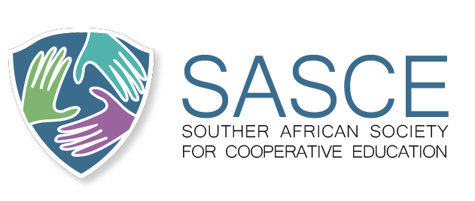s
WIL AFRICA CONFERENCE 2026
CALL FOR CONFERENCE ABSTRACTS

DATE | 29 September – 01 October 2026
VENUE | Wits School of Education, University of the Witwatersrand, Johannesburg, South Africa

CONFERENCE THEME
“Transforming Education through Work-Integrated Learning and Occupational Skills for Africa's Development Agenda: Future-Ready Skills Ecosystems”.

INTRODUCTION

The WIL Africa Conference 2026 invites researchers, academics, industry leaders, policymakers, practitioners, employers, students, and community partners to engage in critical conversations on the future of Work-Integrated Learning (WIL), occupational skills development, and workforce readiness across Africa. As African economies navigate rapid technological disruption, changing labour market demands, the Fourth Industrial Revolution, green transitions, and evolving workplace practices, there is an urgent need to strengthen the relationship between education, skills development, and productive employment. WIL has emerged as a crucial pedagogical and workforce development strategy that bridges learning and work, enhances employability, supports innovation, and contributes to sustainable socio-economic development.
This conference, co-hosted by the Wits School of Education, seeks to explore how higher education institutions, TVET, private colleges, industry partners, professional bodies, governments and communities can collaboratively build future-ready skills ecosystems that prepare graduates and workers to thrive in dynamic and inclusive economies. The conference aims to showcase innovative practices, implementation insights, research findings, policies, partnerships, and technologies that advance WIL and occupational skills development throughout Africa. Researchers and practitioners are invited to submit abstracts that address the conference theme and related sub-themes.

CONFERENCE SUB-THEMES

1 | Reimagining Work-Integrated Learning for Emerging Industries and Future Work

▪ Innovative WIL models post COVID
▪ Preparing graduates for Industry 4.0 and Industry 5.0 workplaces
▪ Artificial intelligence and technology-enabled learning
▪ Digital, hybrid, and virtual workplace learning
▪ WIL for social inclusion and equity
▪ Entrepreneurship and self-employment pathways through WIL
▪ Youth employability and graduate transitions

2 | Strengthening Industry-Education Partnerships for Skills Development

▪ Public-private partnerships in education and skills development
▪ Collaborative curriculum design and assessment practices
▪ Employer engagement and workplace readiness
▪ Sector education & training initiatives and impact evaluation
▪ Rural and community-based WIL initiatives
▪ Skills development for green economies and sustainable futures

3 | Policy, Leadership and Quality Assurance in WIL and Occupational Skills Development(Plenary Theme)

▪ WIL frameworks, policies, and governance (DHET)
▪ Monitoring and evaluation of WIL programmes
▪ Quality assurance and accreditation (QA Bodies)
▪ Leadership in skills ecosystems
▪ Regional, continental, and international perspectives on WIL

4 | Reskilling and Upskilling Lecturers for Future-Ready Teaching, Innovation, and Workforce Development

▪ Industry 4.0 and 5.0 Competencies for lecturers.
▪ Digital Transformation tools and Technology Integration.
▪ Innovative Pedagogies and Work-Integrated Learning in TVET.
▪ Emerging Technologies and Artificial Intelligence in Education.
▪ Enhancing Employability Skills through Lecturer Reskilling Initiatives.
▪ Policy, Practice, and Research on Lecturer Development and Professionalisation.
▪ Entrenching Continuous Professional Development and Lifelong Learning

TRACT SUBMISSION GUIDELINES

▪ Abstracts should be 250–300 words.
▪ Submissions should clearly indicate the relevant conference sub-theme.
▪ Abstracts may report on research, practice-based innovations, policy initiatives, case studies, partnerships, or theoretical contributions.
▪ All abstracts will undergo peer review.
▪ Accepted abstracts will be included in the conference programme and conference proceedings.
▪ Participants can publish in the partnering DHET-accredited journals listed.

IMPORTANT DATES

Call for Abstracts Opens | June 2026
Abstract Submission Deadline | 6 August 2026
Notification of Acceptance | As soon as received.
Conference Dates | 29 September – 01 October 2026
Paper & Abstract Review | Reviews will be on a rolling basis.

CORRESPONDENCE

For enquiries regarding the WIL Africa Conference 2026 and abstract submissions, please contact the conference organising committee.

